

Retro World

LTD corporation

v1, January 2022

White Paper

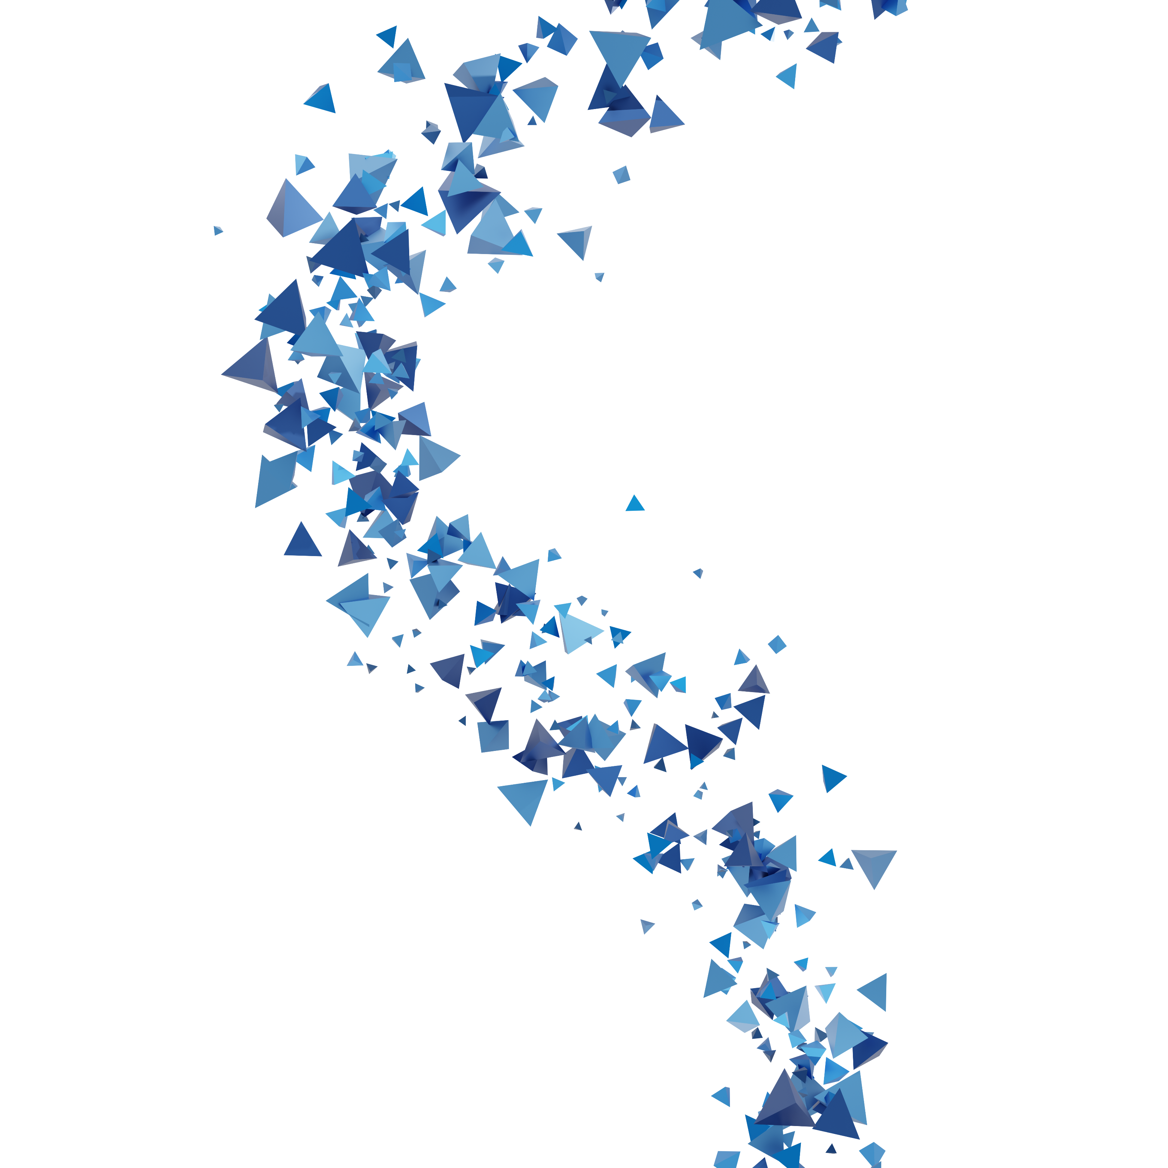

**Disclamer**

SOME LEGAL TEXT

Contents

Abstract 6

Executive Summary 7

Vision 7

Retro World 9

Introduction 9

5W1H 9

Metagame, Multiverse, and Metaverse 10

Projection 11

How it works 12

AI-Powered Style Transfer 12

Immigration 13

Assets 14

In-game assets 14

Verifiable Ownership 14

Game-Chain Connector (SDK) 14

Content 16

Base Reality Experience 16

Parallel Universe Experience 16

Example Parallel Universes 17

Scenario A 17

Scenario B 18

Home Experience 18

Storefront & Exhibition 19

Interactions 19

Proof of Creator Content 20

Burning 20

Mining 21

Blocks 21

Pools 21

The Creator Pool 21

The Community Pool 22

Community, Player Organization, and DAO 22

Tooling 23

Services 24

Trading Assets, Content, and Services 25

Marketplace 25

Social Profile Showcase 26

VR 28

Tokenomics 29

Allocation and Unlock Schedule 29

Governance 29

Staking 29

Payment 29

Techonology 30

Team 30

Roadmap 30

Reference 30

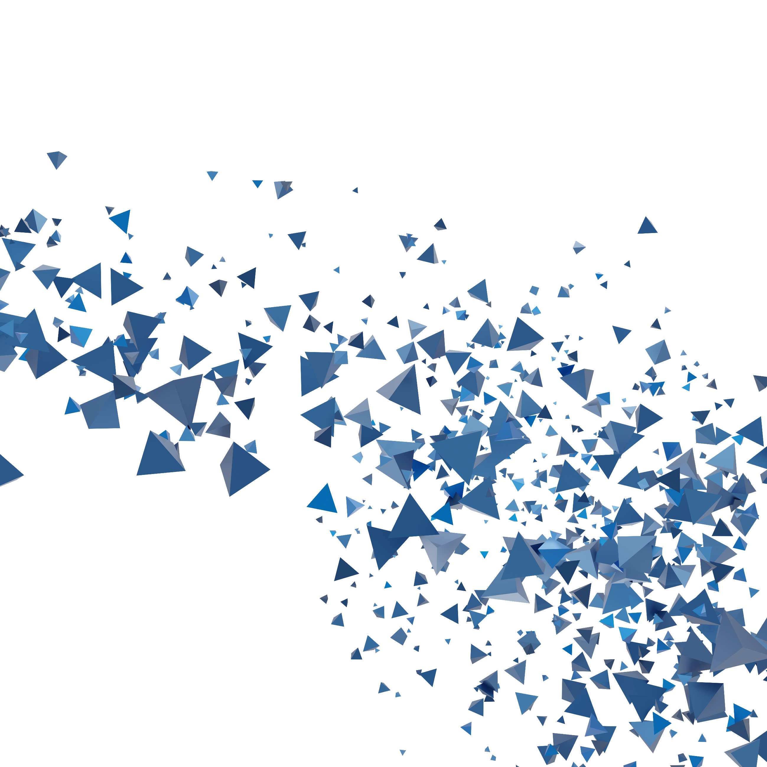INTRODUCTION

Abstract

Technology frequently produces surprises that nobody predicts. In late 2021, both the terms “Metaverse” and “Web 3.0” reached maximum public popularity according to Google Trends. We also observed tech giants as well as startups aggressively revealed plans about constructing their interpretation of Metaverse/Web 3.0 apps, leaving many fundamental questions to the public:

*“How can I get involved?”*

*“Which metaverse should I join?”*

*“Do I own the content I create?”*

We dislike the uncertainty as much as you do.

Therefore, our answers are:

*“...by creating your very own version of metaverse”*

*“...any, or, all of them”*

*“...absolutely Yes!”*

Executive Summary

Vision

[project concenpt pic]

When considered collectively, fans of games, movies, and other media franchises are naturally separated by context. Specifically, context refers to the set of circumstances or facts that surround a particular IP (intellectual property).

While it is common that one individual could be a fan of multiple contexts, there is a lack of a single place that welcomes them all. And this is where the Metaverse concept kicks in: it provides a comprehensive and inclusive reality for all people, no matter where they are from or what they like.

However, up until late 2021, major players in the industry are building “Metaverses” in a narrow sense. In other words, most of them are rushing to create shards of the Metaverse (like VR meetings, online events, etc.) and trying to set “standards” for the metaverse. As the entire “Metaverse” is driven by a single entity, there is a lack of freedom for users to reshape and customize their experience.

We believe in the era of web3.0, users and communities should drive the development of the metaverse, and the metaverse should operate, expand and thrive revolves around user-created content.

Retro World is designed in this way. It is a sophisticated platform and a true web3.0 world that not only bridges traditional web 2.0 applications and the blockchain industry but also acts as a hub for various metaverse experiences. It offers unprecedented interoperability of content, service, and asset across different contexts.

[content services, assets pic]

Retro World

Introduction

“...there is this an almost physical sense of shelter where the story represents a kind of habitation, a kind of home.” John Berger, art critic, and novelist

5W1H

[5W1H info graphics]

What is Retro World? Retro World is a 3D voxel MMO (massively multiplayer online) game.

What does the gameplay look like? It ships with a single giant open world, the only purpose is to provide a playground and canvas for users to have fun.

What activities can I participate in as a regular player? Being a registered user, you may create a personalized avatar and bring any real or imaginary objects into Retro World through “Projection” as well as “Immigration”. You may also join custom experiences created by other users.

What are Phase 1 and Phase 2? Phase 1 is designed as a buffer period to help users get familiar with Retro World:

* Registration
* Avatar creation and initial immigration & object projection
* Build DAO community
* Build player organizations (eg. guild, club, fellowship)
* Community campaign
* Join designated in-game events
* Join official experiences

Phase 2 begins as soon as our game editors are released. Retro World becomes mature in this phase with experiences.

Who build it: initially our team, then users

Who can play it: everyone, there is no restriction or fee to register, download and play the game.

When will Phase 1 and Phase 2 come? Once the game was released, it automatically enters Phase 1. When all the customization tools were released, it enters Phase 2.

Why voxel? We understand that most people have the motivation of creating new, unique, and customized items during the gameplay, but art creation always requires skills and efforts. However, when the entire world is simplified and everything is built with blocks, even untrained players can quickly handcraft desired items or architectures.

Where can I apply early access to Retro World? Please register on our website.

How to play the game? For basic interactions please follow the in-game tutorial and our website, feel free to ask questions on our community channel.

Metagame, Multiverse, and Metaverse

By definition, a metagame is a game about the game, is an approach to a game that transcends or operates outside of the prescribed rules of the game. With Retro World’s editors, players are capable of creating or modifying the rules of a sub-game (aka. parallel universe).

To summarize, Retro World is the combination of the **base reality** (the shared common world) plus a collection of **parallel universes** (user-created universe). We use the term “**Multiverse**” to describe such a structure. Those parallel universes are solely controlled by their creator, with alternated physical rules, environment, narrative, characters, etc. Except for certain resources that are carried in and out, parallel universes are separated from the base reality.

Players can enter a parallel universe to enjoy a totally different immersive gaming experience. For example, there will be a battle royale sub-game created by us, where players fight with modern weapons to survive; while in another sub-game players are expected to team up, and defeat the dark lord together with magic spells. There are also sub-games that serve different purposes, like a bazaar for trading in-game items, or a virtual meeting room for guild member gatherings. Retro World is an entirely connected virtual world that enables users to seamlessly move from one part (e.g., gaming) to another (e.g., dating, shopping, working, or anything else).

With the increasing number of parallel universes, more and more activities can be done in Retro World, thus finally transitioning from a metagame to metaverse.

Projection

We define Retro World as a “Metagame” because it exceeds the narrow sense of how games look like, it does not necessarily have to break “The fourth wall”. Instead, there is no wall at all: players can bring anything into the game, and game content is no longer restricted and owned by the developers: a significant portion of the game content will be decentralized and owned by the community. While we only provide a base reality, players can create their own reality and own it.

To summarize, projection describes the action of mapping one object outside Retro World to the inside.

Being a game designed for everyone, we recognize and respect each player has a comfort zone and each item carries a context. Therefore, we welcome the projection of any item to our game.

How it works

We have native support of popular voxel formats. Users are able to import voxel objects from other applications with one click.

It is also possible to use our voxel editor to create desired objects from scratch.

[pics]

Projecting real-life objects are also made easy, we offer two methods to do this:

Import image then choose a container or frame for it

Import image then apply style transfer to it

[pic: pixel vs hyperrealism]

AI-Powered Style Transfer

For most applications that allow users to create custom avatars/items, one of the most significant pain points is that they look inconsistent. In other words, different users tend to favor different art styles, and when they are displayed side by side in a single world, they introduce a sense of incongruity.

To address such problems, we have incorporated a reputable design team and deep learning experts to build our one-of-a-kind style transfer tool. It is able to convert any image and make it look like a first citizen in our ecosystem, without losing its original characteristics.

This powerful tool is capable of filling the natural gap between different contexts. For example, it might be awkward for a pixel character to see an item in a realistic style. With our style transfer, it will be processed and appear with the same style.

This tool is publicly available for users to create their portraits, and is internally used to handle NFT minting, cross-game asset exchange, and immigration.

Immigration

We use the word “immigration” to describe the process that people from a different context migrate their character and property into our world. Examples:

* A crypto application user (like most GameFi projects or NFT collections) immigrates to the Retro World by binding their crypto wallet, then obtain a unique, styled copy or a certificate of their original crypto assets.
* A regular person uploads a photo of their dog, then uses our style transfer tool which makes it look consistent with the new world, so their new character would also have a similar virtual pet in the game.

We welcome all people from all backgrounds to join and enjoy the real metaverse experience.

[pic: process]

Assets

In-game assets

During the gaming process, players have chances to complete various adventures, quests, or other activities that generate rewards. Again we hand the power of determination to players: whether they want to trade it for other items or crypto, or hold and display it on their profile.

Verifiable Ownership

In the light of fast-growing blockchain technology, more and more assets are mapped to chains and become verifiable. We recognize such verifiability: when mapping on-chain assets to our world, a special tag is attached to the projected asset, indicating it is trackable on the blockchain. Hence, the expensive CryptoPunks portrait owner doesn’t need to worry about others using their NFT for projection: for on-chain assets, we maintain a strict one-to-one mapping, whenever their ownership changes, such changes are automatically applied to mapped in-game assets.

Game-Chain Connector (SDK)

With various use cases mentioned above, our platform is responsible to maintain the interconnectivity among them. Viewing the platform as a whole, both content creators and consumers may find all tools they need to create or enjoy the next-level gaming experience.

We have discovered that the territory of the crypto world and traditional game industry usually does not overlap. Existing tools focus too much on the Play to Earn (P2E) model, unlike them, we hand the decision-making power to users themselves. While blockchain gurus and game developers continue delivering innovation to the world, we decided to offer a bridge that connects both sides: our game-chain connector.

Game-Chain Connector is essentially an SDK (software development kit) targeting game developers. It provides an all-in-one solution and easy-to-use interface that allows any game to interact with popular blockchains.

Major functionalities include:

* Connection to popular crypto wallets
* Query on-chain data
* Managing the mapping between in-game items and NFT
* Bind existing item to NFT or mint in-game item as NFT (NFT-ize)
* Generate in-game items based on the property of NFT (de-NFT-ize)
* Maintain correct ownership of both NFT and in-game item
* Monitoring designated NFTs on various public chains
* One-click connectivity to NFT marketplace

We will provide the SDK as well as demos in many popular programming languages to cover most of the frameworks that developers favor. Developers may choose any subset of the features they want, with maximum flexibility.

Content

[Slogen Empowering the creators to create their own world. WE believe creator content will be the coral/oil of web3.0]

The entire world is made of 2 major parts: PGC (Professionally Generated Content) and UGC (User-generated Content). Generally, PGC delivers higher quality content and is usually created or reviewed by professionals; while UGC spans a border domain but its quality is usually not guaranteed. PGC and UGC include but are not limited to the projection of items, avatar/home design, and implementation of parallel universes.

Both PGC and UGC are crucial to Retro World.

Base Reality Experience

Retro World ships with a massive map that created as the base reality for everyone. It is the world where every player lives (as a symbol of existence), and also the map that new players land on. There are also many instances, or “sub-world”, attached to it.

Notably, during the game operation, we would regularly extend the base map and release sophisticated pre-built parallel universes with different narratives in order to introduce more possibilities to players. Planned releases are:

* “City Hall” for common gatherings
* “Grand Bazaar” for commodities trading
* “Super Pit” for mining materials
* “Stadium” for special online events
* “Battleground” for PvP activities

Parallel Universe Experience

As mentioned before, a parallel universe is a separated copy of Retro World with customized rules, narratives, environment, and/or objectives. Players determine how their parallel universe looks like. It can be a deserted island like The Animal Crossing™ or an epic fantasy like The Lord of the Rings trilogy.

|  |  |  |  |
| --- | --- | --- | --- |
|  | Maps | Rules | Narrative |
| PGC | Created by us  Everyone can join | set by us (eg. disable PvP) | composed by us |
| UGC | Created by users  Only invitees can join | set by users (eg. gravity set to 50%) | composed by users |

Example Parallel Universes

Scenario A

**Middle-earth adventure**

|  |  |
| --- | --- |
| Type | Single Player |
| Narrative | The player plays as a member of The Fellowship of the Ring, they are responsible for safely delivering the One Ring to Mount Doom and destroying it |
| Maps | Shire, Misty Mountains, Rohan, Gondor, Mordor, etc. |
| Content | The player needs to complete a series of quests, defeat monsters, slay the dragon, collect gold and equipment, to finally complete this instance |

Scenario B

**3 v 3 MOBA (multiplayer online battle arena)**

|  |  |
| --- | --- |
| Type | Multiple Player |
| Narrative | Destroy the enemy team’s Nexus to win |
| Maps | Arena rift |
| Content | The player needs to compete with the other team to gain resources, like Dota 2 or League of Legends |

Home Experience

Lands in Retro World are free. It costs almost nothing to settle. While lands are offered on a first-come, first-served basis, there is a hard limit on how many pieces of land a player can occupy.

Starting from choosing the desired location on Retro World, players can place their portrait on a piece of land to claim that they have occupied it. Then, similar to creating a parallel universe, players can build their own homes inside the occupied territory.

Storefront & Exhibition

Being an important feature of Home Experience, every player could open a personal store. The storefront is customizable: apply creativity and invest in its design to attract more customers.

The storefront also serves as a personal exhibition, where players can display NFTs they own, contents they created, as well as services they provide.

Interactions

No man is an island. It is imperative that there should exist a way for different universes to interact. Currently, we observe two types of intra-universe interactions:

Base reality vs. Parallel Universes

Parallel Universes vs. Parallel Universes

Interaction between the base reality and parallel universes is easy to understand: players must enter an alternate reality through the base reality. Such interaction is bi-directional: certain resources from base reality can enter parallel universes and vice versa.

Parallel universes can also talk to each other. For example, one narrative requires the player to collect a specific item from another parallel universe. We give such freedom to players, the sky is the limit.

Proof of Creator Content

The Retro World employs a novel work algorithm called “Proof of Creator Content” (PoCC). In other words, PoCC tries to encourage, on an ongoing basis, that high-quality content is constantly being added. The currency used in PoCC is our utility token: Ruby.

[pic]

Burning

There is a fee (in Ruby) associated with projecting objects as well as creating a new parallel universe. [百分比] of the fee is captured by Creator Pool as well as the Community Pool, and the rest is burnt immediately.

Minting

Every time new content is added, either in PGC or UGC, a certain number of Ruby will be minted and awarded to the creator. Our dynamic algorithm ensures that the output is always greater than the input, thus creating a positive token flow.

Certain in-game activities, like weekly quests and challenges, may also generate Ruby as rewards.

Note that for most small-scale or low-effort content, the reward is one-time only and paid instantaneously, and there is a hard cap on the rate of creation to stop botting/spamming.

Blocks

In a world made of blocks, blocks themselves are valuable resources. Although Ruby is the only currency circulating in the game, players need blocks to build items or structures. Some blocks are cheap while certain blocks are rarer. Players can mine blocks in the Mining Pit parallel universe with a pickaxe.

Pools

The Creator Pool

Designed to award large-scale or high-effort content. It captures fees from transactions and some in-game activities, creators may be eligible to collect extra rewards from the Creator Pool based on content’s quality. It works like equity incentive compensation, but it is the community rather than a single entity that determines eligibility. Based on the number of player reviews and overall scores, the content creator is able to claim rewards from the Creator Pool. Generally, the better review it receives, the higher amount of tokens it can claim.

One key point is that token incentive from the Creator Pool is released linearly, and is subject to change, based on the ongoing content perfection/update and player reviews.

The Community Pool

Designed to ensure that value generated through the game accrues value to the token. The token allocation of this pool will be progressively decentralized as we implement a DAO solution towards a decentralized model.

Participation in community events, like approving/rejecting proposals and giving constructive advice may be qualified for incentives from the Community Pool. We also have planned a periodical content creation contest moderated by the community, in which outstanding content is eligible to receive a one-time award from the Community Pool.

Community, Player Organization, and DAO

We shall enable a section of the marketplace that allows individuals and groups of users to request a certain type of content/services/assets in exchange for a payment of Ruby, contributed by all the requesters.

“No man is an island entire of itself; every man is a piece of the continent, a part of the main.” Large projects imply higher consumption of materials and higher effort, usually, they require a group of creators to collaborate. We implemented a mechanism to handle large projects:

Tooling

We will release a set of tools for content creators to create their own instances (UGC). Tools under development consist of:

|  |  |  |
| --- | --- | --- |
| Tool | Function | Customizable |
| Map Editor | Create maps of any size | Terrain, building,   weather,   obstacles/  paths, etc. |
| Object Editor | Create unique items within the instance  Create characters, NPCs, monsters, and their AI Create spells/magics | Appearance, interactive logic, stats,  drops, etc. |
| Rule Editor | Override the default game behaviors: listen to in-game events, query blockchain information, deploy custom scripts | Physical rules (eg. gravity) Actions allowed (eg. disallow PvP) Events (eg. random thunderstrike) Game flow (eg. victory condition) |

Services

The metaverse and web3.0 are unleashing a wave of new economic opportunities for people around the world. In a recent earnings transcript, one of the most popular game development platforms, Unity, reported that game making is already trending towards far more artists relative to the number of technologists. This informs how the metaverse will grow as well.

Expected service providers contain artists, modelers, dialog writers, dialog writers, avatar designers, videographers, fashion designers, programmers, and countless other forms of creativity.

Trading Assets, Content, and Services

Marketplace

Recall that Content, Services, and Assets are the three core components in our ecosystem, and there should be a mechanism to help users trade them without borders. Therefore, here we introduce our one-of-a-kind Marketplace.

|  |  |
| --- | --- |
| Tradability | Example |
| Assets | NFTs, in-game items, etc. |
| Content | Character outfits, special blocks, decorations, etc. |
| Services | Projection services, design services, etc. |

We understand many existing platforms allow users to trade on-chain assets safely and efficiently. However, given that the current NFT market is dominated by ETH-based smart contracts, its high gas fee is stopping regular users from trading NFTs. Also, while other public chains have the same capability of distributing NFT, cross-chain transactions and cross-chain swaps are still loaded with trivial details and are expensive.

To address such segmentation between chains and to allow crypto assets to become interoperable, we introduce our cross-chain NFT marketplace. Powered by [Cross-chain tech], it is able to penetrate all potential user bases. Sellers and buyers could select whatever target chain (including Layer 2) they prefer (eg. Ethereum, Binance Smart Chain, Cardano, Polygon, etc.) to trade NFTs. We believe the more accessible to NFTs, the higher the chance of capturing additional users and network value.

[Talk about content trading]

[Talk about services trading]

Social Profile Showcase

It has been proven that social features are crucial to enhance user engagement. They are interactive elements that resemble social media and form the in-game community that can be presented in various ways.

Each registered user will be given a permanent link to their public profile page. On the page, they have the capability to show off their recent in-game activities, progress, achievements, and collections they own.

One key social feature the social profile page offers is the personalized user card.

A popular NFT project: CryptoPunks, has demonstrated that even the simplest elements (24 x 24 pixel portrait) can become a trending phenomenon. However, like other NFT collections, one of the most significant cons is that people cannot build an intuitive connection from the NFT digital art to an actual person. Considering Twitter, for example, users’ avatars always come with user names. One can easily build a portrait that represents himself.

With our effort reinventing the idea of NFT portrait, users can be more creative on a larger canvas. Additionally, their usernames can also be included. Such portraits are more like a mini personal profile, or “business cards” that can be used everywhere. It also contains statistics about the owner’s contribution, including the amount of approved DAO proposals, objects projected, etc.

Users with accounts on our platform may create customized portraits from scratch. Starting from picking the rendering style, users may select a wide range of customizable elements to assemble their unique portraits. Importing in-game assets and displaying them is also possible. Besides the free-for-all parts, certain visual elements are rarer and can only be obtained from in-game events or the marketplace.

The profile showcase also supports add-ons. A couple of add-on slots are reserved so that users could import their equipment images or pet images from the game. With infinite customization possibilities, each profile is unique.

We expect the social portrait to act as a social identity, thus even NFT portraits are solely owned by users, we do not encourage trading them as they carry the original owner’s mark. Additionally, although the NFT cannot be altered once minted, it contains a URL in its metadata to the original owner’s profile page, which can be updated frequently.

Any NFT item players own in the game can be shown on their profile page. Players have the freedom to choose whatever NFT they would like to show. NFT display is not limited to those minted within our ecosystem, users are able to bind multiple public chains then perform mix-and-match on their profile page.

Moreover, Retro World is deeply integrated with Social Profile Showcase, which means many in-game assets, stats, activities can be synced to the owner’s profile.

VR

Most commonly, the Metaverse is misdescribed by mass media as a virtual reality. In truth, virtual reality is merely a way to experience the Metaverse. As a corollary to the above, VR headsets aren’t the mandatory pieces of equipment to experience Retro World, they just boost the existing experience by offering a higher level of immersiveness.



Contacts